Leetcode question
Count Operations to Obtain Zero - LeetCode
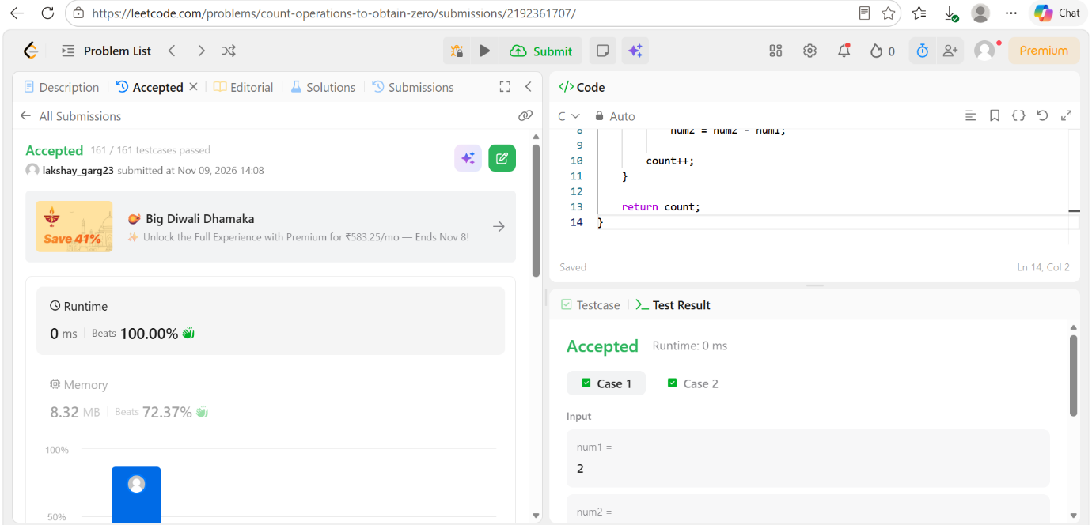

Code
int countOperations(int num1, int num2) {
int count = 0;

while (num1 != 0 && num2 != 0) {
if (num1 >= num2) {
num1 = num1 - num2;
}
else {
num2 = num2 - num1;
}

count++;
}

return count;
}

